# Section 19.6: The Funeral of the Blessed One

After the Blessed One had passed into final Nibbāna, Venerable Anuruddha, with great calm and mindfulness, instructed Venerable Ānanda to inform the Mallas of Kusinārā.  
Hearing the sorrowful news, the Mallas — overwhelmed by grief and longing — rushed to the sāla grove where the Blessed One's body lay in serene repose beneath the twin sāla trees.

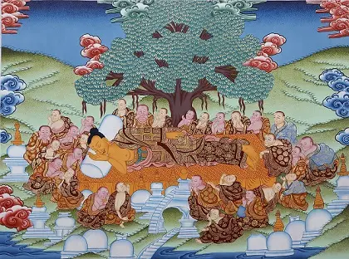

**With reverence and heavy hearts, the Mallas paying final honours to the Tathāgata’s body [1]**

With reverence and heavy hearts, they bowed low before the Tathāgata’s body. Then, desiring to honour the Teacher who had given them the priceless gift of the Dhamma, the Mallas brought perfumes, garlands, fine garments, and gathered musicians from all around.

For six full days they remained there, enveloping the sāla grove in a festival of devotion.  
They adorned the area with awnings and circular canopies, and paid homage through offerings of dance, song, and music — expressions of both sorrow and deep gratitude for the life of the Fully Awakened One.  
Thus, human devotion and heavenly reverence merged, as beings both seen and unseen offered their final respects.

On the seventh day, the Mallas said:

*"We have paid fitting homage to the Blessed One. Now let us carry his sacred body out through the south gate and perform the cremation."*

Eight Malla chiefs, after washing their heads and donning new garments, approached to lift the Blessed One’s body. Yet, despite all efforts, they found themselves unable to raise it.

Puzzled and concerned, they went to Venerable Anuruddha, who, through his divine vision, explained:

*"Vāseṭṭhas, your intention is one thing, but the devas' intention is another."*

He revealed that the devas wished to honour the Blessed One by carrying his body to the **north of the city**, bringing it **through the north gate**, **through the heart of the city**, and **out through the eastern gate** to the shrine of **Makuta-Bandhana** — there to be enshrined and cremated with the highest honours.

Humbly accepting this, the Mallas said:

*"If this is the devas’ intention, so be it."*

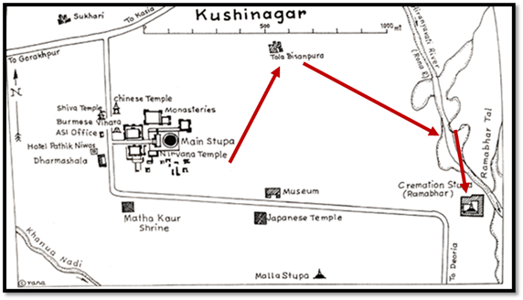

**A map illustrating the location of the parinibbana site on the left-hand side, from where the Buddha’s remains were carried to the Ramabhar cremation site on the right-hand side. [2]**

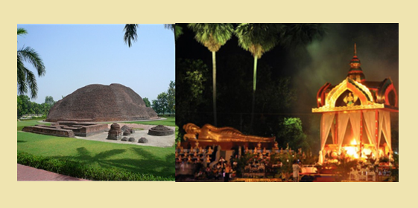

**Left: Ramabhar stupa, the place of the Buddha’s cremation, Right: Impression of cremation ceremony [3]**

### Miracles happened in Kusinara

At that sacred hour, a wondrous sight appeared: the city’s sewers and rubbish-heaps became miraculously covered knee-deep with fragrant coral-tree flowers, as if the very earth itself wished to pay homage.

And so, accompanied by celestial and human music, adorned with flowers and scents both earthly and divine, the Blessed One's body was borne through the city of Kusinārā in a final, majestic procession of love and veneration.

At Makuta-Bandhana shrine, according to ancient custom, they wrapped the Tathāgata’s body as one would the body of a universal monarch. A funeral pyre of the finest fragrant woods was prepared with utmost care and reverence.

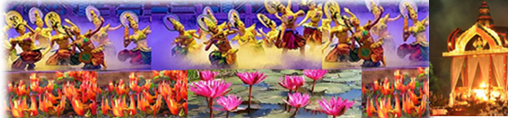

**An artist’s impression: Heavenly musicians and dancers following the Blessed One body carried by Malla Chiefs on Kusinara Streets adorned with heavenly and earthly flowers**

Four Malla chiefs, after purifying themselves and putting on fresh robes, attempted to light the pyre. Yet again, they found themselves unable.

Perplexed, they sought Venerable Anuruddha’s guidance.  
Once more, he answered with gentle insight:

*"Vāseṭṭhas, your intention is one thing, but that of the devas is another."*

He revealed:

*"The Venerable Mahā Kassapa, the great elder, is even now approaching from Pāvā with a large company of monks. The funeral pyre will not ignite until the Venerable Mahā Kassapa has arrived and offered his final homage at the feet of the Blessed One."*

Hearing this, the Mallas respectfully agreed,

*"If this is the devas’ intention, so be it."*

Thus, the sacred rites waited — for it was only fitting that the greatest among the disciples, the Venerable Mahā Kassapa, whose faith was firm as a diamond, should offer the final earthly act of reverence to the Master before the Blessed One’s body was returned to the elements.

## A Great Disciple Paying His Final Respects to His Great Teacher

While the Blessed One undertook his final journey to Kusinārā, the Venerable Mahā Kassapa, the great elder among the Saṅgha, was practicing austerities in a distant forest, guiding a large community of monks with unwavering diligence.

As the Blessed One neared his Mahāparinibbāna, Venerable Mahā Kassapa was walking along the main road from Pāvā to Kusinārā, accompanied by five hundred noble disciples. Along the way, he paused beneath a tree to rest and there met an ājīvika ascetic traveling from Kusinārā.

He asked the man:

*"Friend, do you know of our Teacher?"*

The ājīvika replied:

*"Yes, friend, I do. The ascetic Gotama passed away seven days ago. I picked this coral-tree flower from the place where he lay."[4]*

At these words, a deep stillness fell upon the company.  
Those monks whose minds were not yet freed by wisdom wept, overcome by sorrow. But those who had realized the nature of impermanence endured mindfully, contemplating:

*"All compounded things are impermanent. What is the use of grieving?"*

Yet not all hearts were pure. Among them, the monk Subhadda, who had gone forth late in life, spoke with irreverence:

*"Enough of this weeping! We are well rid of the Great Ascetic, who often restrained us. Now we may do as we please!"*

Hearing these words, the Venerable Mahā Kassapa rebuked them with the authority of deep realization:

*"Friends, enough! Has not the Blessed One told us again and again that all things dear and delightful are subject to change and separation? Whatever is born, become, and compounded must decay. How could it be otherwise?"*

Thus, steadying the Saṅgha with the Dhamma itself, Venerable Mahā Kassapa pressed onward to Kusinārā. Arriving at the Mallas’ shrine of Makuta-Bandhana, where the Blessed One's body lay in state, he approached with profound reverence. Uncovering one shoulder in the traditional gesture of respect, he placed his joined palms in homage.  
Circumambulating the funeral pyre three times, he then uncovered the feet of the Blessed One and, kneeling with deepest devotion, bowed his head to touch them.  
The five hundred monks, his faithful companions, followed him in that sacred act.

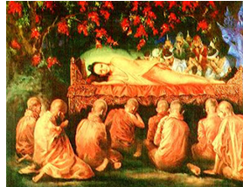

**The Great Disciple’s Final Homage to the Great Teacher [5]**

And at that moment — when the heart of the Saṅgha, embodied in Mahā Kassapa’s devotion, united with the body of the Teacher — the funeral pyre spontaneously ignited, as if the very elements themselves honoured the Great Departure.

Thus, the final homage was completed: not by lamentation, but by the pure, unshakable faith rooted in understanding and love.

The devotion of Mahā Kassapa reminds us that true reverence is not in outward mourning, but in deep fidelity to the Dhamma — in living the teachings with courage and faith.  
Even as the physical form of the Blessed One returned to the elements, the living flame of the Path was entrusted to those who, like Mahā Kassapa, upheld it with unwavering purity.

### The Final Bow

Along the dusty, silent road,  
a noble company made their way;  
with heavy hearts but steadfast steps,  
they bore their grief into the day.

A whisper through the coral trees,  
a flower fallen from the skies —  
the word had come: the Teacher gone,  
beyond all worlds, beyond all ties.

Some wept with clinging, some with fear;  
some spoke with hearts yet bound to self;  
but one great elder, still and clear,  
held fast the treasure of true wealth.

Beneath the pyre, where silence reigned,  
Mahā Kassapa bowed low his head;  
three times he walked, three times he wept —  
not with despair, but love instead.

He touched the Blessed One’s worn feet,  
the feet that walked the Deathless Way;  
and at that touch, the pyre blazed bright —  
the earth and heavens wept and swayed.

O faithful heart, O steadfast friend,  
you bore the torch beyond the end;  
and in your bow, the Path endured —  
the Dhamma's light forever pure.

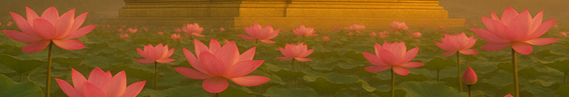

### The Last Homage

Beneath the coral-blossomed skies,  
the Awakened One lay still;  
and hearts of gods and men alike  
bowed low to love and will.

With song and scent, with dance and tears,  
they honoured what words could not say;  
for one who taught the way beyond,  
was resting now, beyond decay.

Through silent streets they bore him forth,  
through gates of east and north and south;  
a city's grief, a heaven’s joy,  
woven in garlands of the mouth.

The fire awaited; yet the flame  
could rise not without holy sign —  
for Mahā Kassapa must first bow low,  
a final touch, a final shrine.

So stands the path for those who see:  
no hurried step, no clinging hand;  
but faith and homage, pure and free,  
in rhythm with the Deathless Land.

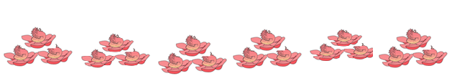

**Dhamma Reflections:**

The funeral of the Blessed One reminds us that even at the closing of his earthly life, the universe itself bowed in reverence. Human devotion and celestial homage flowed together — a testimony to the boundless compassion, wisdom, and purity of the Tathāgata.

The patient waiting for Mahā Kassapa also teaches a timeless lesson: true devotion is beyond urgency; it moves in harmony with Dhamma, with reverence and profound mindfulness.  
When the heart stands still in faith and gratitude, it reflects the stillness of Nibbāna itself.

Thus, even in the Blessed One’s final rites, the Dhamma shines forth — as a guide, a refuge, and a gentle reminder that beyond birth and death, there is the Unconditioned, the Deathless.

### The Sacred Division of the Tathāgata's Remains

When the Blessed One’s body was finally consumed by the sacred fire, what had been flesh, sinew, and fluid vanished entirely — only the luminous relics remained, pure and shining.  
No ash, no dust — just as butter burns away leaving no trace — so too the body of the Supreme One dissolved, leaving behind only the imperishable bones.

All five hundred layers of fine garments, from the innermost to the outermost, were consumed completely by the flames.

And when the great burning was complete, a wondrous event occurred:  
a cooling shower of water fell from the sky, and another from the sāla trees themselves,  
as if the heavens and the earth, in loving devotion, sought to soothe the sacred pyre.

The Mallas, too, poured perfumed water upon the embers, honouring their Lord with the fragrance of devotion. For a week afterward, the Mallas of Kusinārā honoured the relics in their assembly hall, surrounding them with a lattice-work of spears and a wall of bows,  
celebrating with dances, music, garlands, and heartfelt homage — not in sorrow alone, but in deep veneration and gratitude.

### The News Spreads: The World Gathers

As the news of the Blessed One’s Mahāparinibbāna spread across the land, kings, chieftains, and noble families — followers of the Buddha’s way — journeyed to Kusinārā.  
Among them came:

* King Ajātasattu of Magadha,
* the Licchavis of Vesālī,
* the Sakyans of Kapilavatthu,
* the Bulayas of Allakappa,
* the Koliyas of Rāmagāma,
* and the Brahmins of Vethadīpa.

All stood before the Mallas and said:

*"We are worthy of the Lord’s relics. Allow us each a portion to enshrine and honor!"*

But the Mallas, with deep attachment, declared:

*"The Lord passed away in our land. We will not share His relics!"*

Tensions rose swiftly — the noble ones, grieved and desperate, argued fiercely, ready even for battle over the sacred remains.

Then, in that heated moment, a voice of wisdom arose:  
the Brahmin Dona, a devoted lay follower of the Blessed One, remembering the Dhamma of peace, stood and proclaimed:

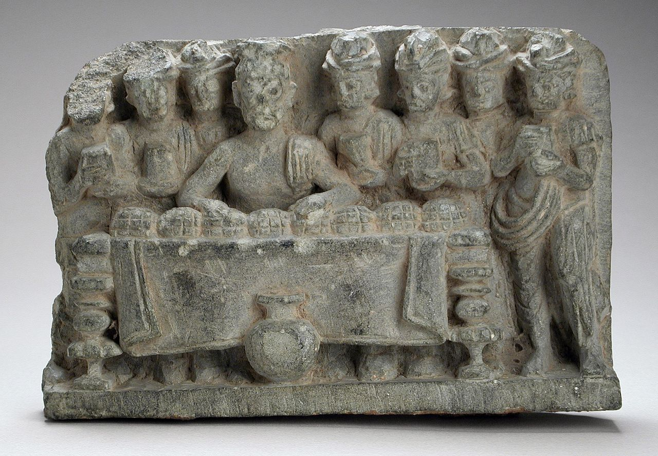

**The Distribution of the Buddha's Relics, by Dona the Brahmin. [6]**

### The Brahmin Dona’s Verse

*"Listen, lords, to my proposal.  
Forbearance is the Buddha’s teaching.  
It is not right that strife should come  
From sharing out the best of men’s remains.  
Let’s all be joined in harmony and peace,  
In friendship sharing out portions eight:  
Let stupas far and wide be put up,  
That all may see — and gain in faith!"*

Hearing the wisdom in Dona’s words, remembering the spirit of the Great Teacher,  
the assembled leaders consented:

*"Very well, Brahmin, divide the relics fairly!"*

And so, Brahmin Dona divided the relics into eight equal portions.  
He requested the urn for himself, wishing to erect a stupa for it, and this request too was granted with honour.

Shortly after, the Moriyas of Pipphalavana arrived, requesting a share of the relics.  
Finding none left, they accepted the embers with reverence.

Thus, great stupas were built:

* King Ajātasattu at Rājagaha,
* the Licchavis at Vesālī,
* the Sakyans at Kapilavatthu,
* the Bulayas at Allakappa,
* the Koliyas at Rāmagāma,
* the Brahmins at Vethadīpa,
* the Mallas at Pāvā and Kusinārā,
* Brahmin Dona for the urn,
* and the Moriyas at Pipphalavana for the sacred embers.

**Thus were the relics of the Supreme Teacher enshrined across the sacred lands, scattering seeds of faith for generations to come. [7]**

**Note**: In Appendix 1describes the present location of the relic stupas

**Dhamma Reflection:**

Even after the Tathāgata’s final passing, his presence remained — not in one place, not in one form, but in the awakened hearts of those who remembered his teachings. The relics became outward symbols of the inner treasure:  
the Dhamma, the living inheritance of all who walk the path with faith, effort, and wisdom.

It was not by might, nor by pride, but by harmony and sharing that the true honour was paid to the Blessed One.

In this way, the Perfectly Enlightened One's compassion continued to shine —  
guiding his disciples to peace, even in the hour of greatest loss.

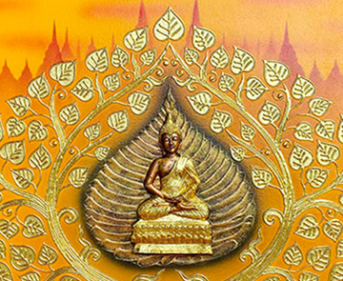

### "The Flame That Does Not Die"

Upon the earth, the Teacher lay,  
his mortal form returned to sky;  
yet in the hearts of those who know,  
the Dhamma’s flame shall never die.

Relics rest in silent shrines,  
where flowers fall and waters flow;  
but wisdom lights the inner road,  
where seeds of faith forever grow.

The body burns, the world may change,  
but truth stands bright, unshaken, free;  
O children of the Awakened One,  
walk on — the Path is destiny.[8]

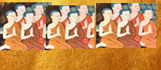

With these inspiring words we will conclude this compilation. Following is our sincere and respectful gratitude to the Blessed One, The Dhamma and the Sangha



### Final Dedication: Offering of Gratitude **[9]**

With hearts full of reverence,  
we bow to the Blessed One, the Perfectly Enlightened Teacher,  
whose compassion has opened the path to the deathless for the world.

We bow to the Dhamma, the radiant law of truth,  
shining through all ages as the sure refuge for the wise.

We bow with deepest gratitude to the Sangha —  
to all the noble sons and daughters of the Buddha,  
those who have gone before,  
those who walk now,  
and those yet to come —  
guardians of the path, bearers of the living Dhamma,  
whose virtue and realization uphold the light —

even across twenty-six thousand years and more!

As humble lay followers, with palms joined in devotion,  
we offer our deepest appreciation and boundless joy.  
Because of you, O noble Sangha, the teachings endure,  
the path remains visible, and faith continues —

to blossom in countless hearts.

May this humble work be a fragrant offering  
at the feet of the Buddha, the Dhamma, and the Sangha,  
a whisper of gratitude carried by the winds of time,  
for the welfare, the happiness, and the liberation of all beings.

Sabbe sattā bhavantu sukhitattā.  
May all beings be happy!

### END Notes: Section 6

1. Source: <https://www.exoticindiaart.com/article/parinirvana/>
2. Source: <https://www.thailandfoundation.or.th/buddhism_meditatio/the-buddhas-cremation-and-its-legacy-on-thai-funeral-practices/> ((Credit: [KUSHINAGAR Description and Short History](https://blogs.ubc.ca/asia250buddhistsites/kushinagar/)))

   <https://blogs.ubc.ca/asia250buddhistsites/kushinagar/>
3. Replica Cremation Ceremony of the Buddha at Wat Phra Borom That Yang Temple in Thailand. Buddha <https://www.thailandfoundation.or.th/buddhism_meditatio/the-buddhas-cremation-and-its-legacy-on-thai-funeral-practices/>
4. DN:16
5. Source: <http://www.myanmarnet.net/nibbana/dawn_01.htm>
6. <https://en.wikipedia.org/wiki/Allakappa#/media/File:The_Distribution_of_the_Buddha's_Relics_LACMA_M.84.151.jpg>
7. DN:16
8. Picture source: <https://royalthaiart.com/product/golden-buddha/>
9. Picture source: <https://en.dhammakaya.net/our-activities/asalha-puja-day/>